1. Display all flight numbers which has Business class.

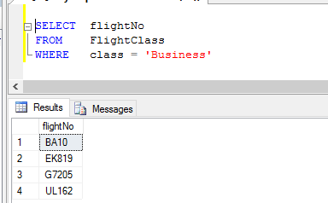

1. 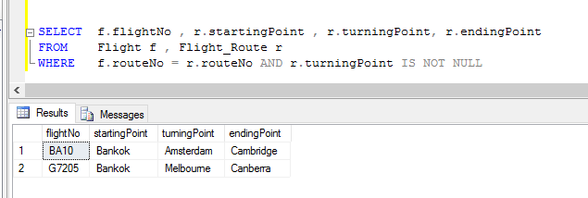Display flightNo and relavant route order which have not a direct route.
2. 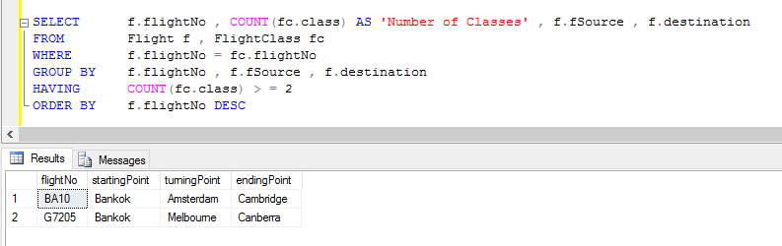Each flight has different kind of travel classes. Display flight numbers that are having at least two classes. Display flight number, Number of classes, source and destination according to the descending order of flight number.
3. 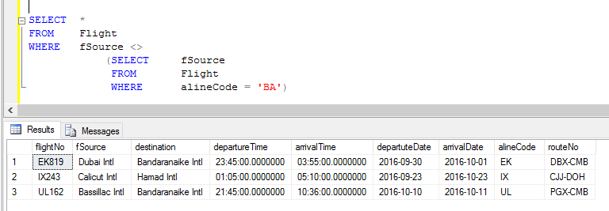Find the flight details which one's source is not same as alineCode is 'BA'.
4. Display plane details that landed in an airport which plane 'LN_TUJ' was landed.

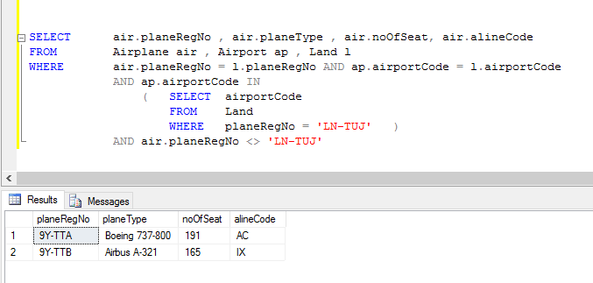

1. Display all the Airline name which have alinecode starting with ‘B’.

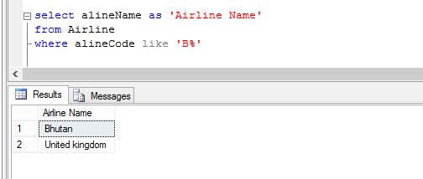

1. Display Passenger first name & last name with Address who was booking ticket in Travel Agency where in ‘colombo’.

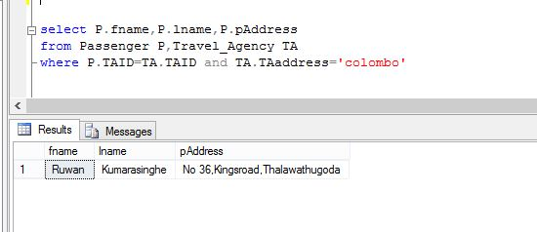

1. Display All the Passengers Names who has more than 1 Contact.

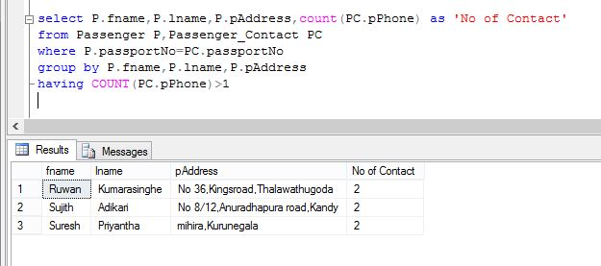

1. 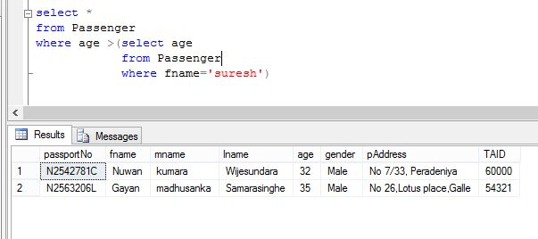Find the All details who has age greater than suresh
2. Find the pasengers where first name have 'a' letter and age less than 30. Display Name,Age and gender

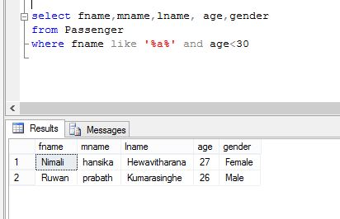

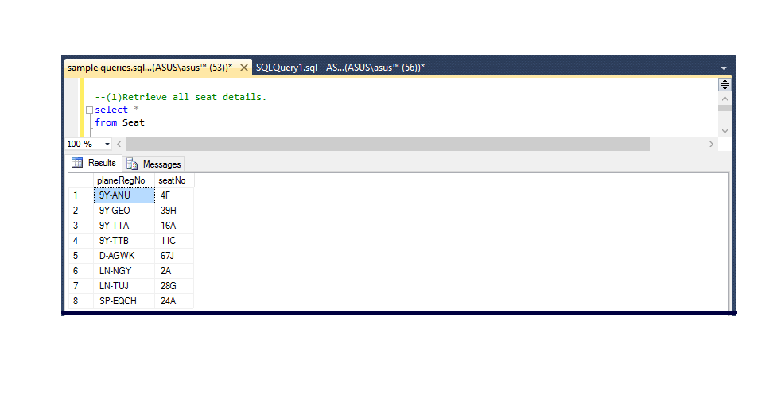11. Retrieve all seat details.

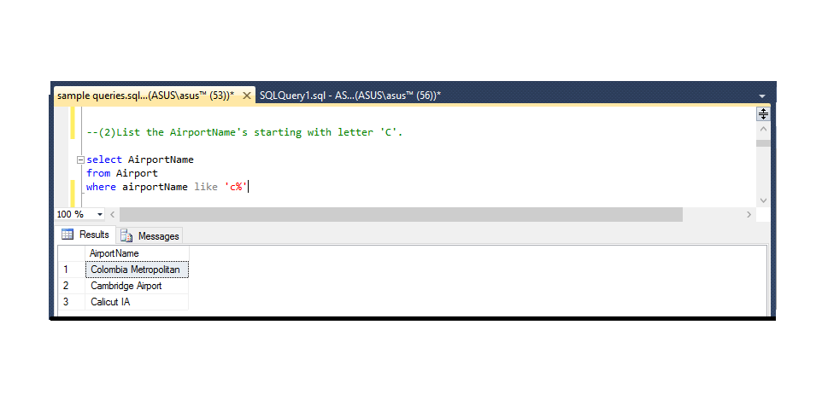

12. List the airport names starting with letter ‘c’.

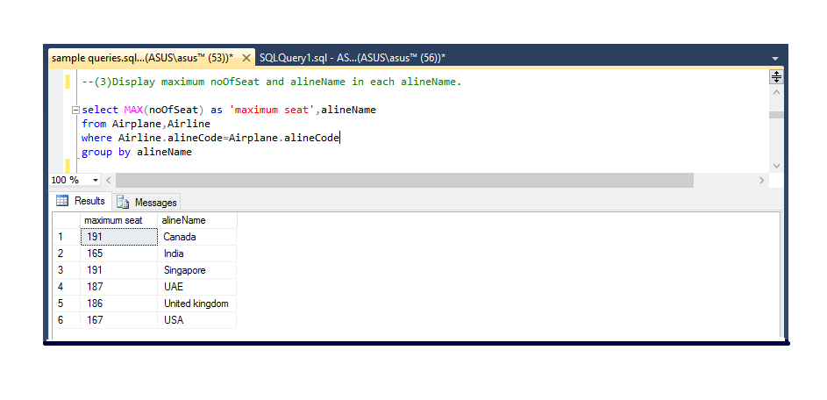13. Display the maximum seat in each aline name.

14. Display the passport no, fname, lname whose age is greater than 28 years old.

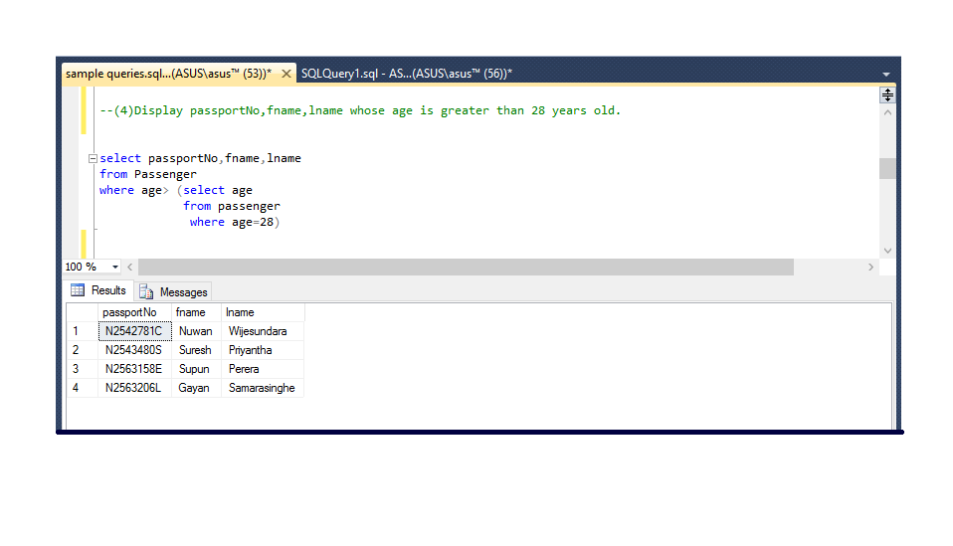

15. Count the no of passenger in each TAID. 